* To become familiar with using arrays and array lists
* Creating an array table
* To Sum + Average + get the MAX and MIN using arrays
* Using loops with arrays

**There are 3 challenge exercises each worth 33.3%**

An array variable can hold multiple values of the SAME type (integer or String) types

Int [] numbers >> the [] brackets make the numbers variable an integer array

Subscripts are the numbers that are assigned in arrays, and they always start with 0

Numbers [0] = 100;

Numbers [1] = 200;

Numbers [3] = 300;

Numbers [4] = 400;

Numbers [5] = 500;

**Project #1**

When an array is out of bounds? Means when the array index is greater than the array length

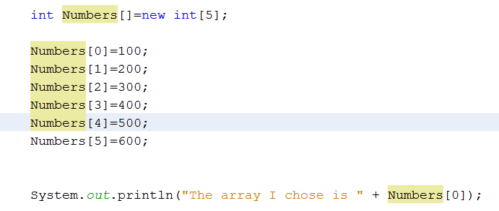

**Project #2**

1-D Array List Array

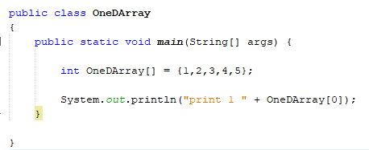

2-D List Array

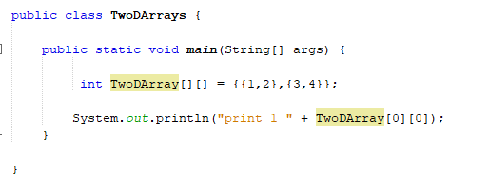

3-D List Array

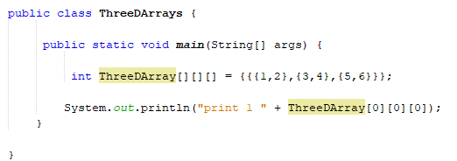

**Project #3**

**Adding arrays:**

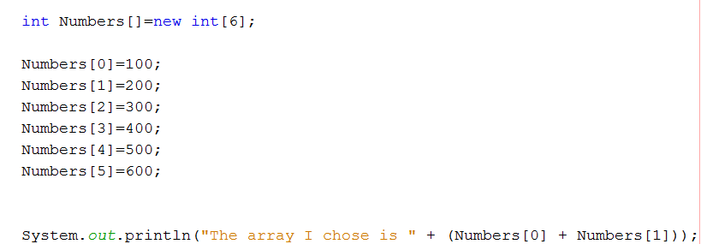

**Project #4**

**Using a Loop to retrieve all arrays:**

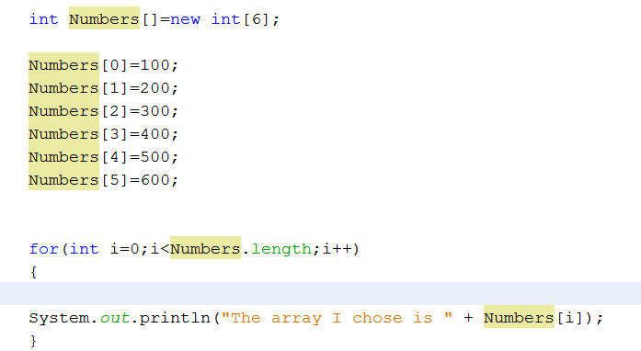

**Project #5**

**Getting the sum and average for all arrays:**

Add two variables

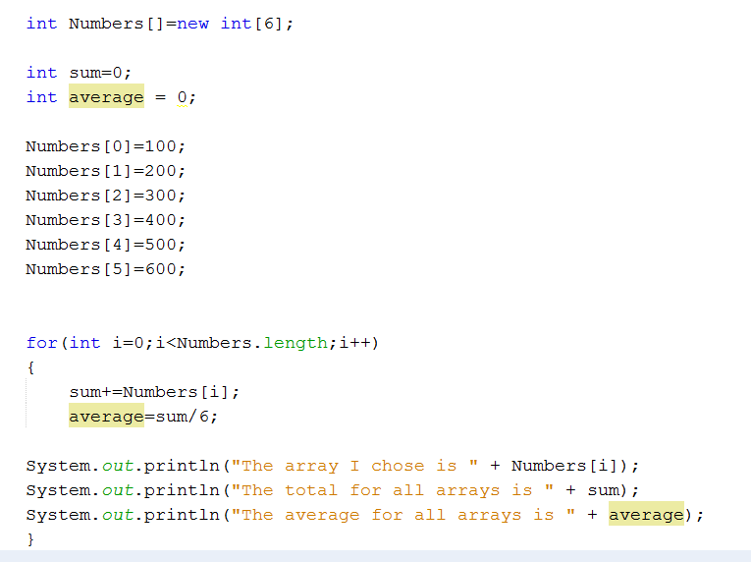

Get the sum and average

# Take out the + from the +=sum

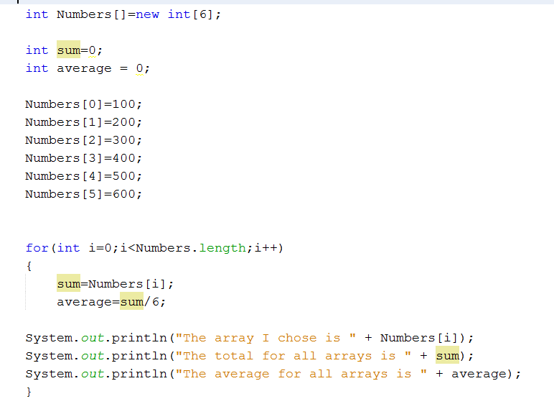

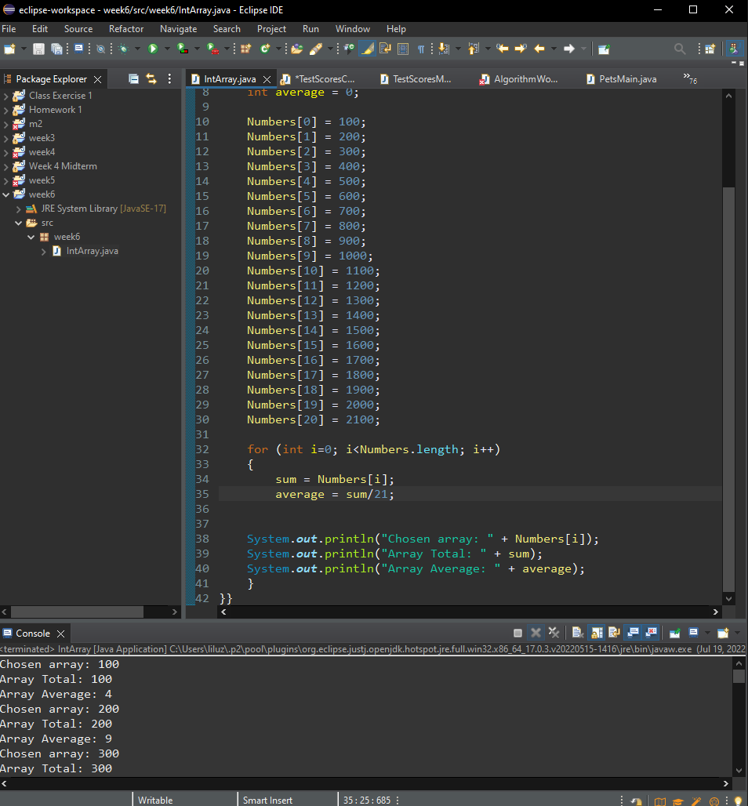

**Challenge Exercise #1:** The variable names reference an integer array with 20 elements. Write a for loop that print each element of the array. Be sure to SUM and AVERAGE the numbers in the array.

**#1 print screen the output with the code below here.**

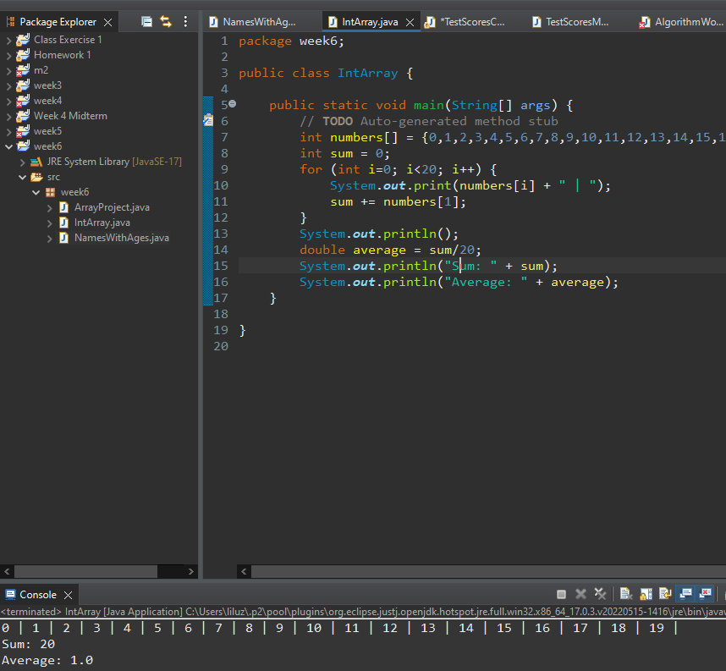

**Project #6**

**Create a new class and name it ListArrays:**

A list array is an array that lists numbers or characters in a list and the array numbers are NOT visible

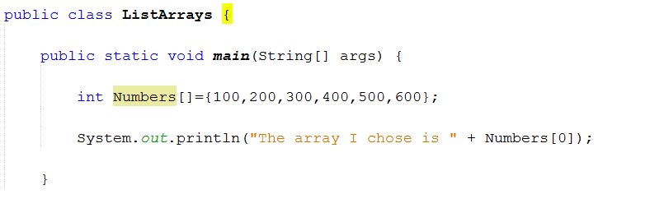

**Where are the numbers?**

int Numbers [] = {100,200,300,400,500,600};

0 1 2 3 4 5 (Index numbers)

Character List arrays

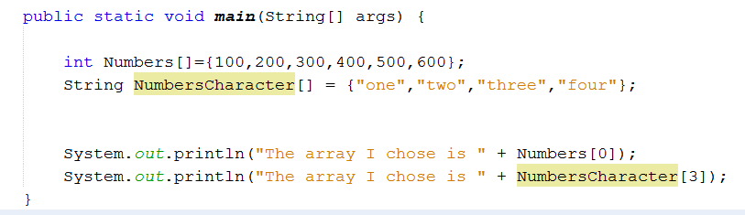

**Challenge Exercise #2:** Create an array(s) that will list the names with ages as shown below.

* + Jane, Bob, Bill, and Howard
* Create 1 integer array with the following ages
  + 21, 22, 23 and 24
* The output will be as shown below

Screen Clipping

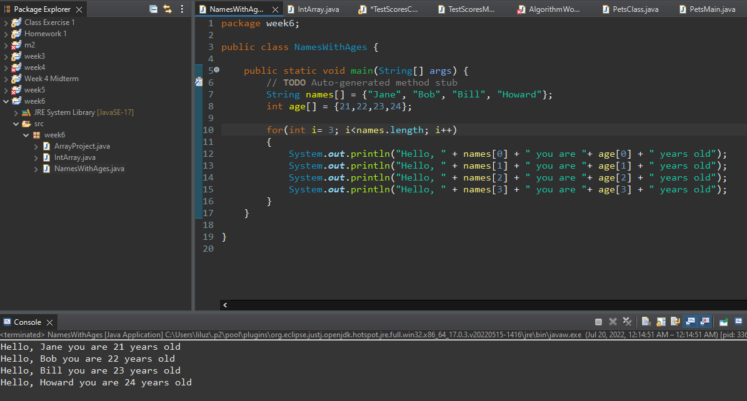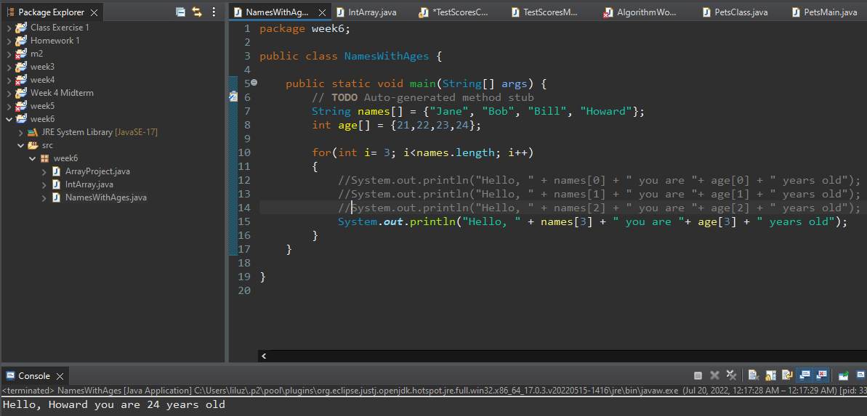**#2 print screen the output with the code below here.**

**Project #7**

**Create a new class and name it InputArrays & Math Class**

* Here is an example how we can input into console and get an output from an array using a Math Class

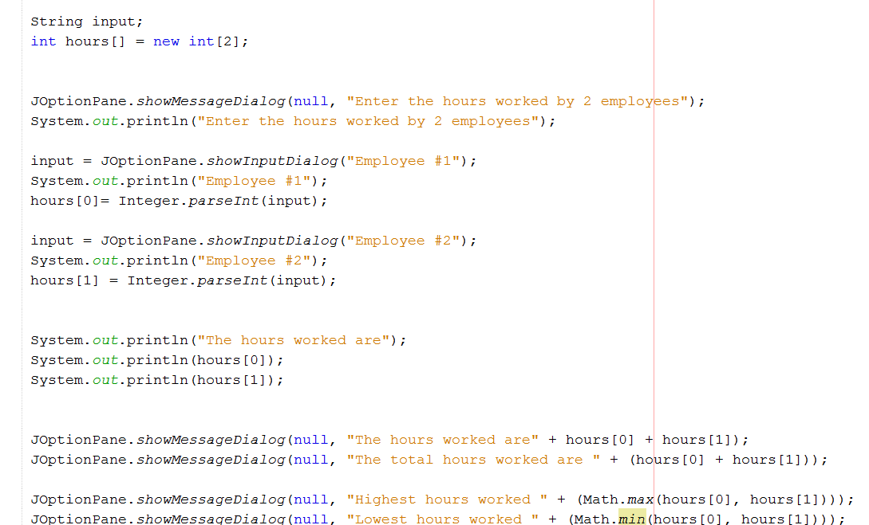

**Project #8**

**Using a JOptionPane to input**

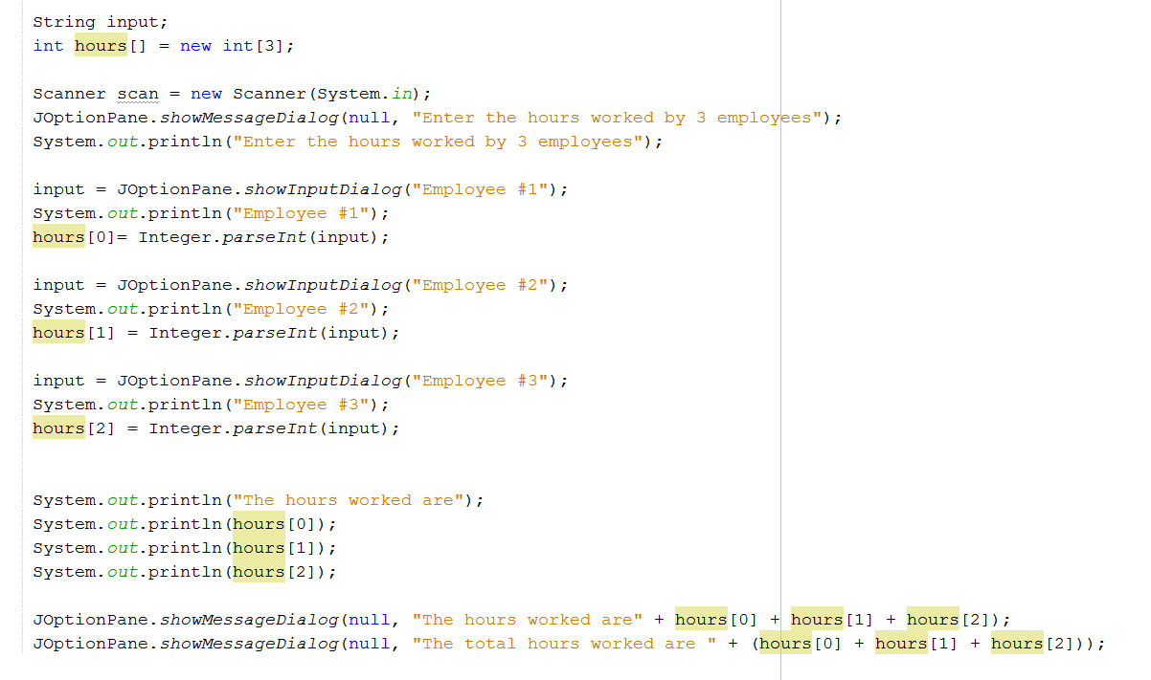

**Project #9**

**Create a new class and name it SalesArray**

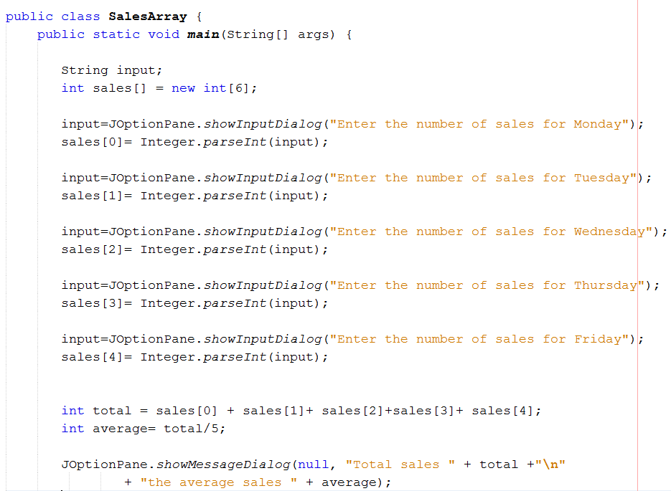

**Project #10**

**Using parallel arrays**

**Project #11**

**Passing arrays to methods**

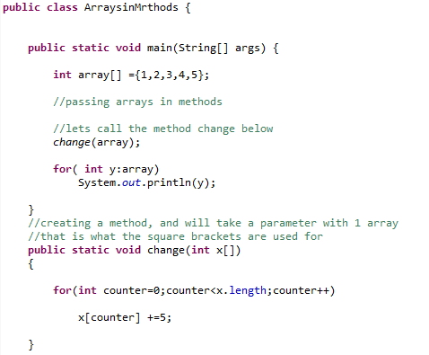

**Totaling the arrays**

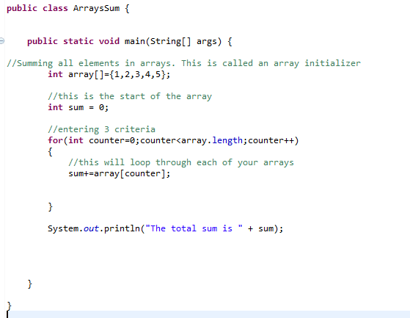

**Project #12**

**Creating a multi-dimension array**

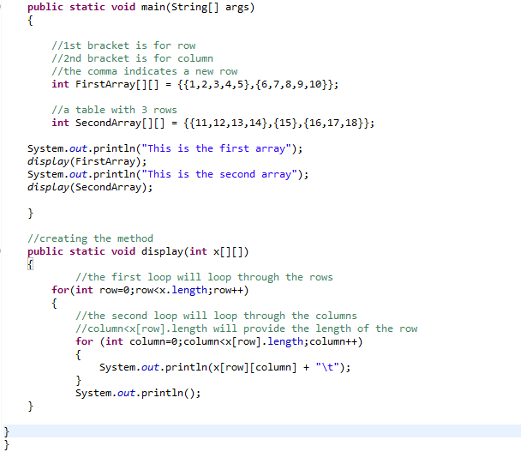

**Challenge Exercise #3:** Create a 3-D array for the numbers 10,20,30,40,50,60,70,80,90 and retrieve the number 50

Create a 2-D array for the numbers 100,200,300,400 and retrieve the number 300

**#3 print screen the output with the code below here.**

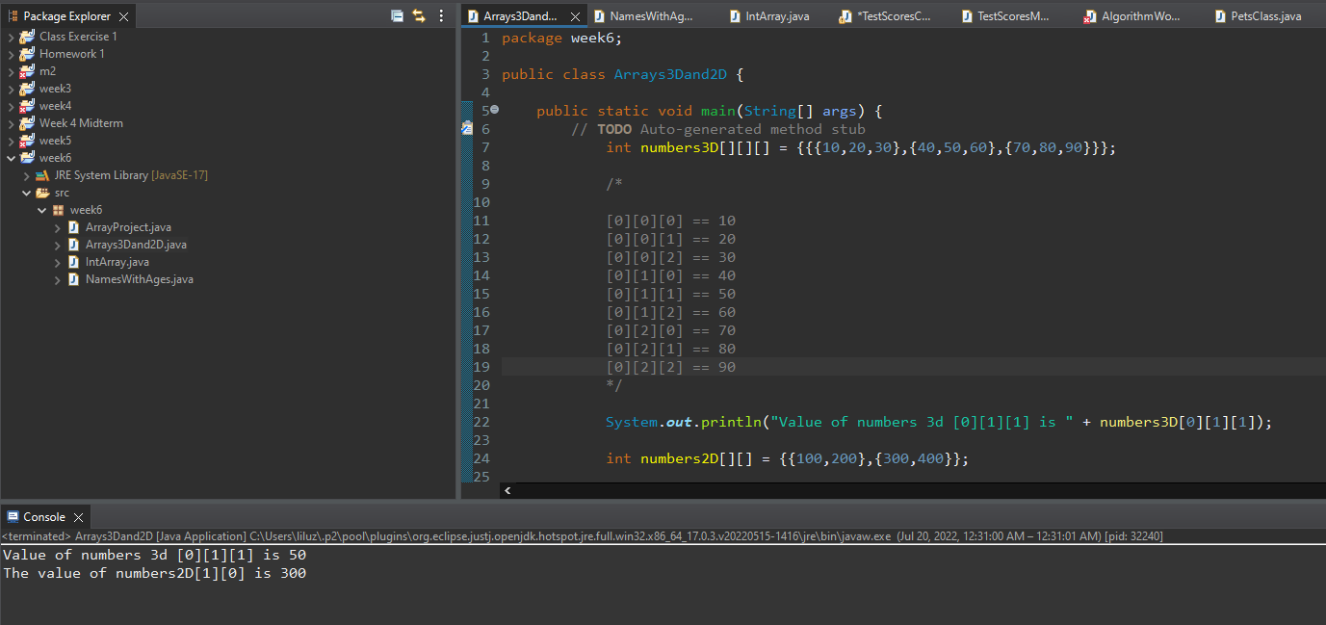

**Submit this document to Module 6 Class Exercise.**